|  |  |
| --- | --- |
| ARU Peterborough logo | **ARU Peterborough**  **Mobile Games Development** |

Texturing the simple “Treasure Chest” we made using Blender.

**Aim**: To find out how to texture our simple “Treasure Chest” using BLENDER

**Objectives:** At the end of the session, you should be able to…

* Recap of what we will be trying to make.
* Create a simple **MATERIAL**.
* Adding a second **MATERIAL** and **ASSIGNING** this to part of the model.
* Reusing **MATERIAL** on other parts of the model (i.e., the **LID**)
* Completing the texturing of the “Treasure Chest”

**Introduction to software:**

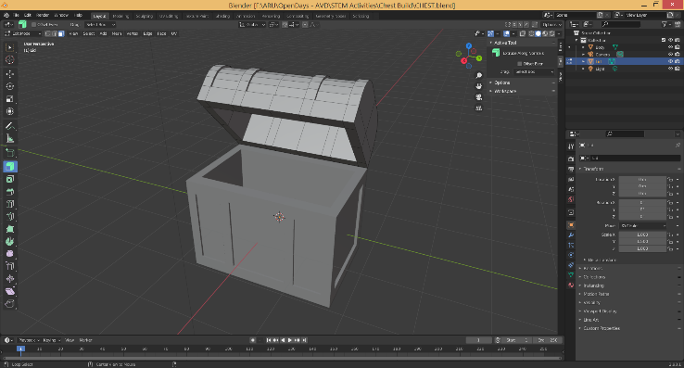

**BLENDER** is a free piece of software used mainly by indie games developer but is starting to be more popular with larger games companies. This software allows you to create simple 3D models used for all types of animations, games and VR experiences.

This can be downloaded at <https://www.blender.org/>

# **Activity 1:**

**Aim:** Recap what we will be trying to make.

For this worksheet we will be looking at texturing the simple “Treasure Chest” we made using the basic tools in BLENDER. These textures will not be perfect and will still make our chest look very “cartoon like”. We also will not be going into much depth regarding how to texture a 3D object correctly. But this will give you a simple idea of how to quickly add some texture/colour to our model to get a better idea to how the final image could look.

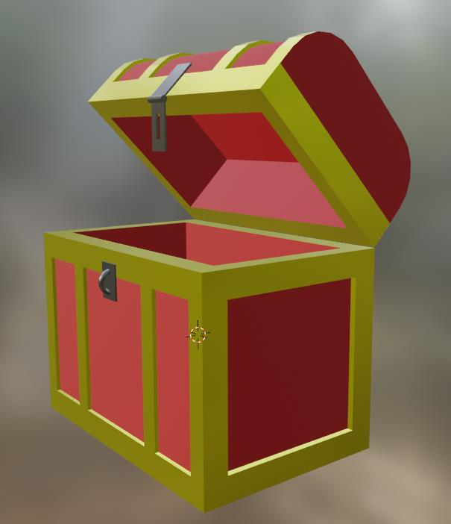

# **Activity 2:**

**Aim:** Create a simple **MATERIAL**.

To start texturing a simple stylised object (like this chest) the best thing to do is texture the whole object first in one colour. Then you can later change what needs altering.

The first thing to do is to create a **MATERIAL**. **MATERIAL** is what you will wrap around the object to add some colour or make the object look more realistic.

**TASK**:

The first thing to do is SELECT one part of your chest. I would start with the **BODY**. You do this by CLICKING on the **BODY** object in the **SCENE COLLECTION**.

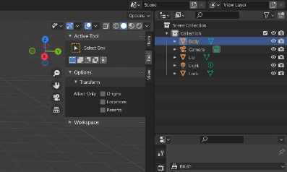

You now need to change the **MODE** to **EDIT MODE**…

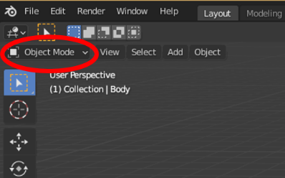

**TASK**:

On the right-hand side of the screen, you need to SELECT the **MATERIALS PROPERTIES** menu (It should be the last of the options on the list. Leaving your mouse over the **ICONS** will tell you what these items are) …

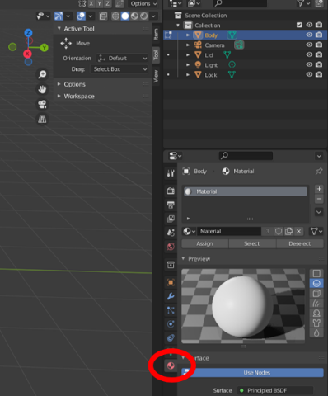

By selecting this option, you should see a menu like above.

**TASK**:

Now we need to create our first **MATERIAL**, which will be for the **BANDS**.

First, we need to **LABEL** the **MATERIAL** correctly. To do this CLICK on the 3rd “**MATERIAL**” on the menu and RENAME this “**M_BANDS**”. We use “**M_**” to highlight that this is a **MATERIAL**.

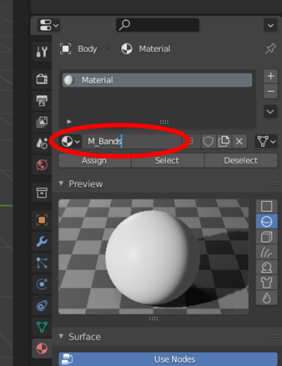

By PRESSING **ENTER**/**RETURN** on the keyboard you will notice that **MATERIAL** title found above this will also change to the same name.

**TASK**:

Next, I prefer to do some simplifying of the screen. I like to **HIDE** what I do not need. So, the first thing I do is **MINIMISE** the **PREVIEW** area. This is done by PRESSING the little **DOWNWARDS ARROW** beside the title of **PREVIEW**.

Then I CLICK on the “**USE NODE**” button to **MINIMISE** this part of the screen. We only need to see the simple **MATERIALS** options. You will know it is **MINIMSED** as the “**USE NODE**” button will change from **BLUE** to **GREY**.

After all the **MINIMISING** the **MATERIALS PROPERTIES** menu should look like this….

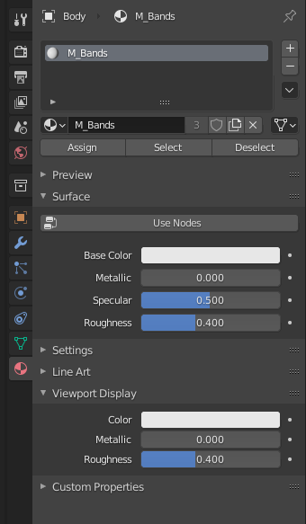

**TASK**:

Next is to pick the colour we want for the **BANDS**. For my example I picked a **GOLD** colour, but you can make this whatever colour you want.

First where it shows the **SUBMENU** of **SURFACE**, CHANGE the **BASE COLOR** by CLICKING on the **WHITE BOX** beside it. Then from the **COLOUR WHEEL** PICK your colour.

Once you have selected your colour you will see the **CHEST** changes to the colour you picked. Do not worry about all of the chest becoming this colour as we will change the elements that we do not want to be **GOLD** later.

I next want to make this **GOLD** to appear more like “shinny metal”. So, to do this I alter some of the setting below the **BASE COLOR**.

I CHANGED the following…

**METALLIC = 0.8** (1 really metallic/shinny. 0 is non-metallic looking)

**SPECULAR = 0.5** (this is how reflective it will be)

**ROUGHNESS = 0.2** (the lower the number the smoother it appears)

…. but you can set this **MATERIAL** to appear however you want.

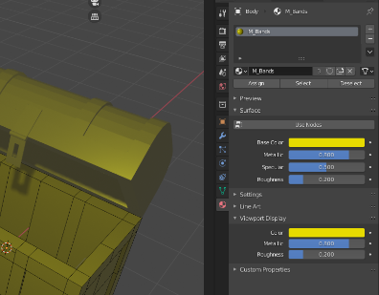

Now if you MOVE the **X, Y, Z** compass you can check this **MATERIAL** to see if it is right for your **CHEST**. Remember this material is for the **BANDS**. We will change the rest next.

# **Activity 3:**

**Aim:** Adding a second **MATERIAL** and **ASSIGNING** this to part of the model.

We do not want to have a **GOLD** chest, so why have we made it all **GOLD**?

The reason for make this the first colour and not the **RED** is that if you look at the **BANDS** you will notice they sit slightly proud of the **CHEST**. They have a very small side to them which is very hard to select. So, I decide to materialise the **RED** sections as they are larger and easier to select.

**TASK**:

We need to create a second **MATERIAL** now for the **RED** sections of the **CHEST**.

First CLICK on the **+** symbol to add a new **MATERIAL**.

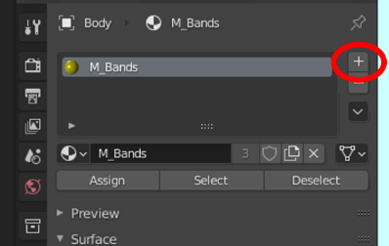

**TASK**:

This will add a new **EMPTY** **MATERIAL** to the list of **MATERIALS**. You need to then CLICK on where it now says **NEW**.

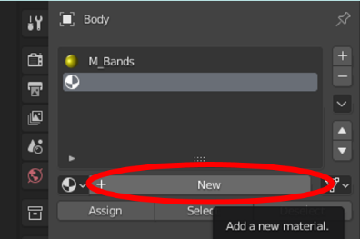

This will then name this new **MATERIAL** … “**MATERIAL**”.

Rename it “**M_BODY**”, and then PRESS **ENTER**. This will add **M_BODY** to the list of **MATERIALS**.

Then again **MINIMISE** the options on this **MATERIAL** **PROPERTIES** menu by CLICKING on the “**USE NODE**” button.

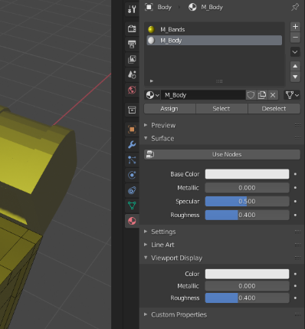

**TASK**:

What you now need to do is CHANGE the **SETTINGS** for this new **MATERIAL** so that it appears like how you would like the **BODY** of the chest to appear. I chose a **DARK** **RED** for mine, but you could pick any colour of your choice.

As this will not be metal, I have made my setting ….

**METALLIC = 0.0**

**SPECULAR = 0.5**

**ROUGHNESS = 0.8**

…. but you could set this to be whatever you think looks right.

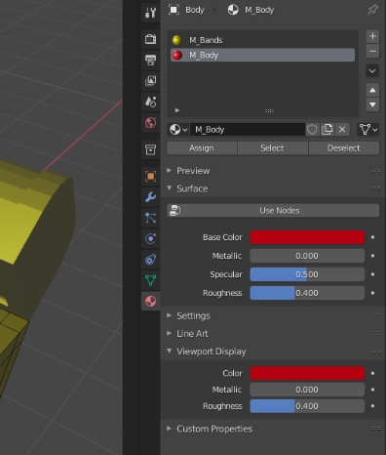

Unlike before this will not change the colour of the chest YET, as this time we will need to **ASSIGN** the **MATERIAL** to the areas we want this **MATERIAL** to appear.

**TASK**:

To use this **MATERIAL** on the chest. Set the **VIEWPOINT** (using the **X, Y, Z** compass) to **X**, so you can see the front of the chest.

Now CHANGE the **SELECTION** option to **FACE SELECT** (top left-hand corner of the screen).

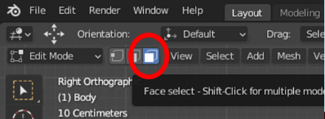

SELECT all the sections (within the **BODY** only) which you want the new **MATERAILS** to appear.

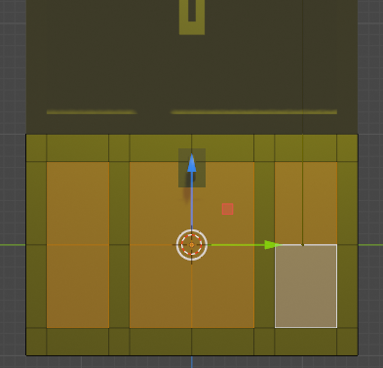

**TASK**:

Now from the **MATERIAL PROPERTIES** menu CLICK on **M_BODY** from the **MATERIALS LIST**. Then CLICK the **ASSIGN** button….

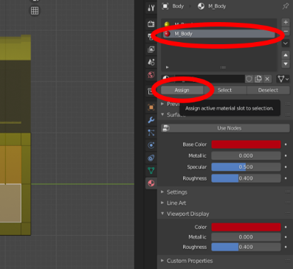

You should now see the sections that should not be **GOLD** (which are not the **BANDS**) are now a different colour (mine being **RED**).

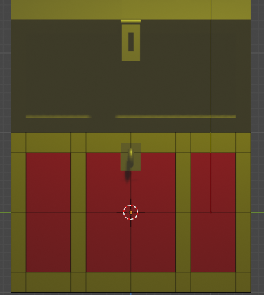

**TASK**:

All that is left to do is **REPEATING** this process to CHANGE the **FACES** for the **BODY** of the **CHEST** to this new **MATERIAL** where appropriate.

**REMEMBER** to do this to the **INSIDE** areas of the **CHEST** and the **BOTTOM**.

# **Activity 4:**

**Aim:** Reusing **MATERIAL** on other parts of the model (i.e., the **LID**)

Now that the **BODY** of the **CHEST** has been completed, you now need to ADD a **MATERIAL** to the **LID**. For this we will not need to create any new **MATERIALS**, as we can reuse the ones we created for the **BODY**.

**TASK**:

SELECT the **LID** from the **SCENE COLLECTION**.

Make sure that you CLICK on the **SMALL** **DOT** beside the **TITLE** to change this to being the **SQUARE** icon.

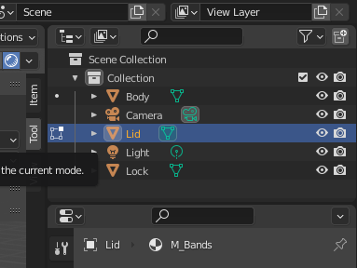

**TASK**:

In the **MATERIAL PROPERTIES** you will notice that only **M_BANDS** appears, and that the **M_BODY** has disappeared. This is because it belongs to the **BODY** section of the model only.

We need to **ADD** this **M_BODY MATERIAL** to the **LID**.

To do this you need to again PRESS the **+** symbol to add a new **MATERIAL**.



Now instead of PRESSING **NEW**, like we did before, this time PRESS the little **DROPDOWN ARROW** beside it to open the **MATERIALS BROWSER** list.

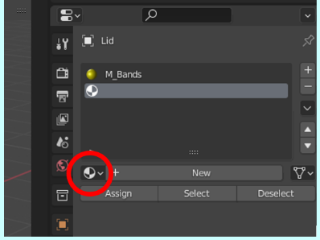

From the **MATERIALS BROWSER** SELECT **M_BODY**. The previously used **MATERIAL** will now appear in your **MATERIALS LIST**.

**TASK**:

As you did with the **BODY** of the **CHEST**, SELECT all the **FACES** that you want in the **M_BODY** **MATERIAL**, and **ASSIGN** the correct **MATERIAL**.

REMEMBER to **ADD** this new **MATERIAL** to the **INSIDE** of the **LID**.

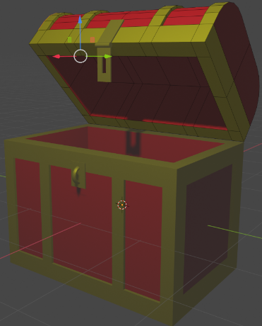

# **Activity 5:**

**Aim:** Completing the texturing of the “Treasure Chest”

Your “Treasure Chest” should now start to look a little more like a “Treasure Chest” – be it very stylised.

**TASK**:

If you have any additional features to your “Treasure Chest”, like that of a **LOCK** or **HANDLES**, maybe create some additional **MATERIAL** to make them look slightly different.

Maybe the inside of the **CHEST** could have a different **MATERIAL**, to represent it being lined with fabric for example?

